Prototype-CPL

|  |  |
| --- | --- |
| **Student Name/ID Number:** | Wildan Luqmanul Hakim/STTB |
| **Academic Year:** | 2022 |
| **Unit Assessor:** | Arvinder Kaur |
| **Project Title:** | CPL-Project prototype |
| **Issue Date:** | 28 February 2023 |
| **Submission Date:** | 3 March 2023 |
| **Internal Verifier Name:** |  |
| **Date:** | 3 March 2023 |

|  |
| --- |
| **Learner declaration** |
| I certify that the work submitted for this assignment is my own and research sources are fully acknowledged.    Student signature: Date: 3 March 2023 |

**Project Prototype**

Link Prototype : <https://www.figma.com/proto/0oc5ULIxVjAbsDt9b2GZHL/E-Warehouse?page-id=0%3A1&node-id=133%3A123&viewport=828%2C-196%2C0.09&scaling=min-zoom&starting-point-node-id=133%3A123>   
Link UI Design : <https://www.figma.com/file/0oc5ULIxVjAbsDt9b2GZHL/E-Warehouse?node-id=133%3A426&t=DSr6Z1vjwk8sQkGF-1>

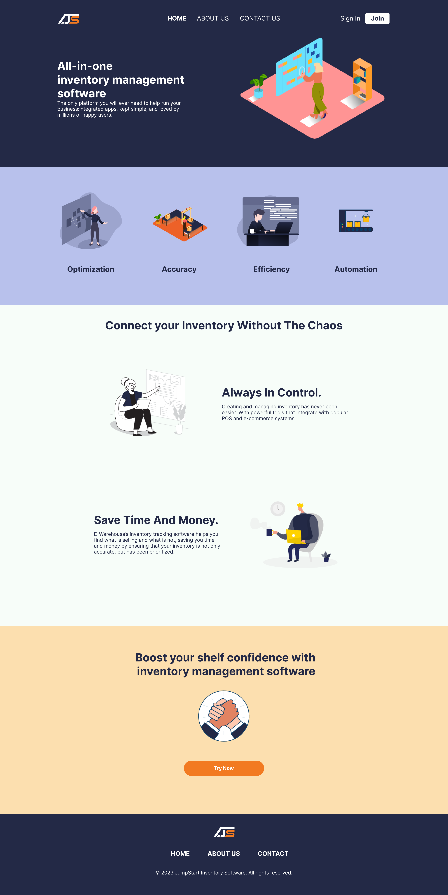  
Landing Page

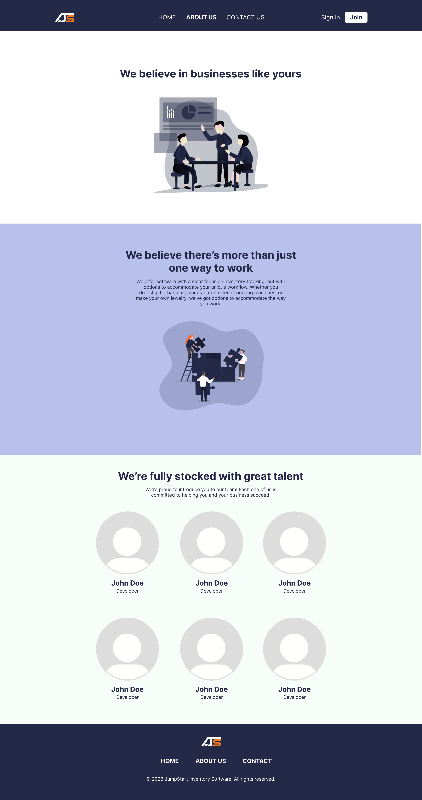

About Us

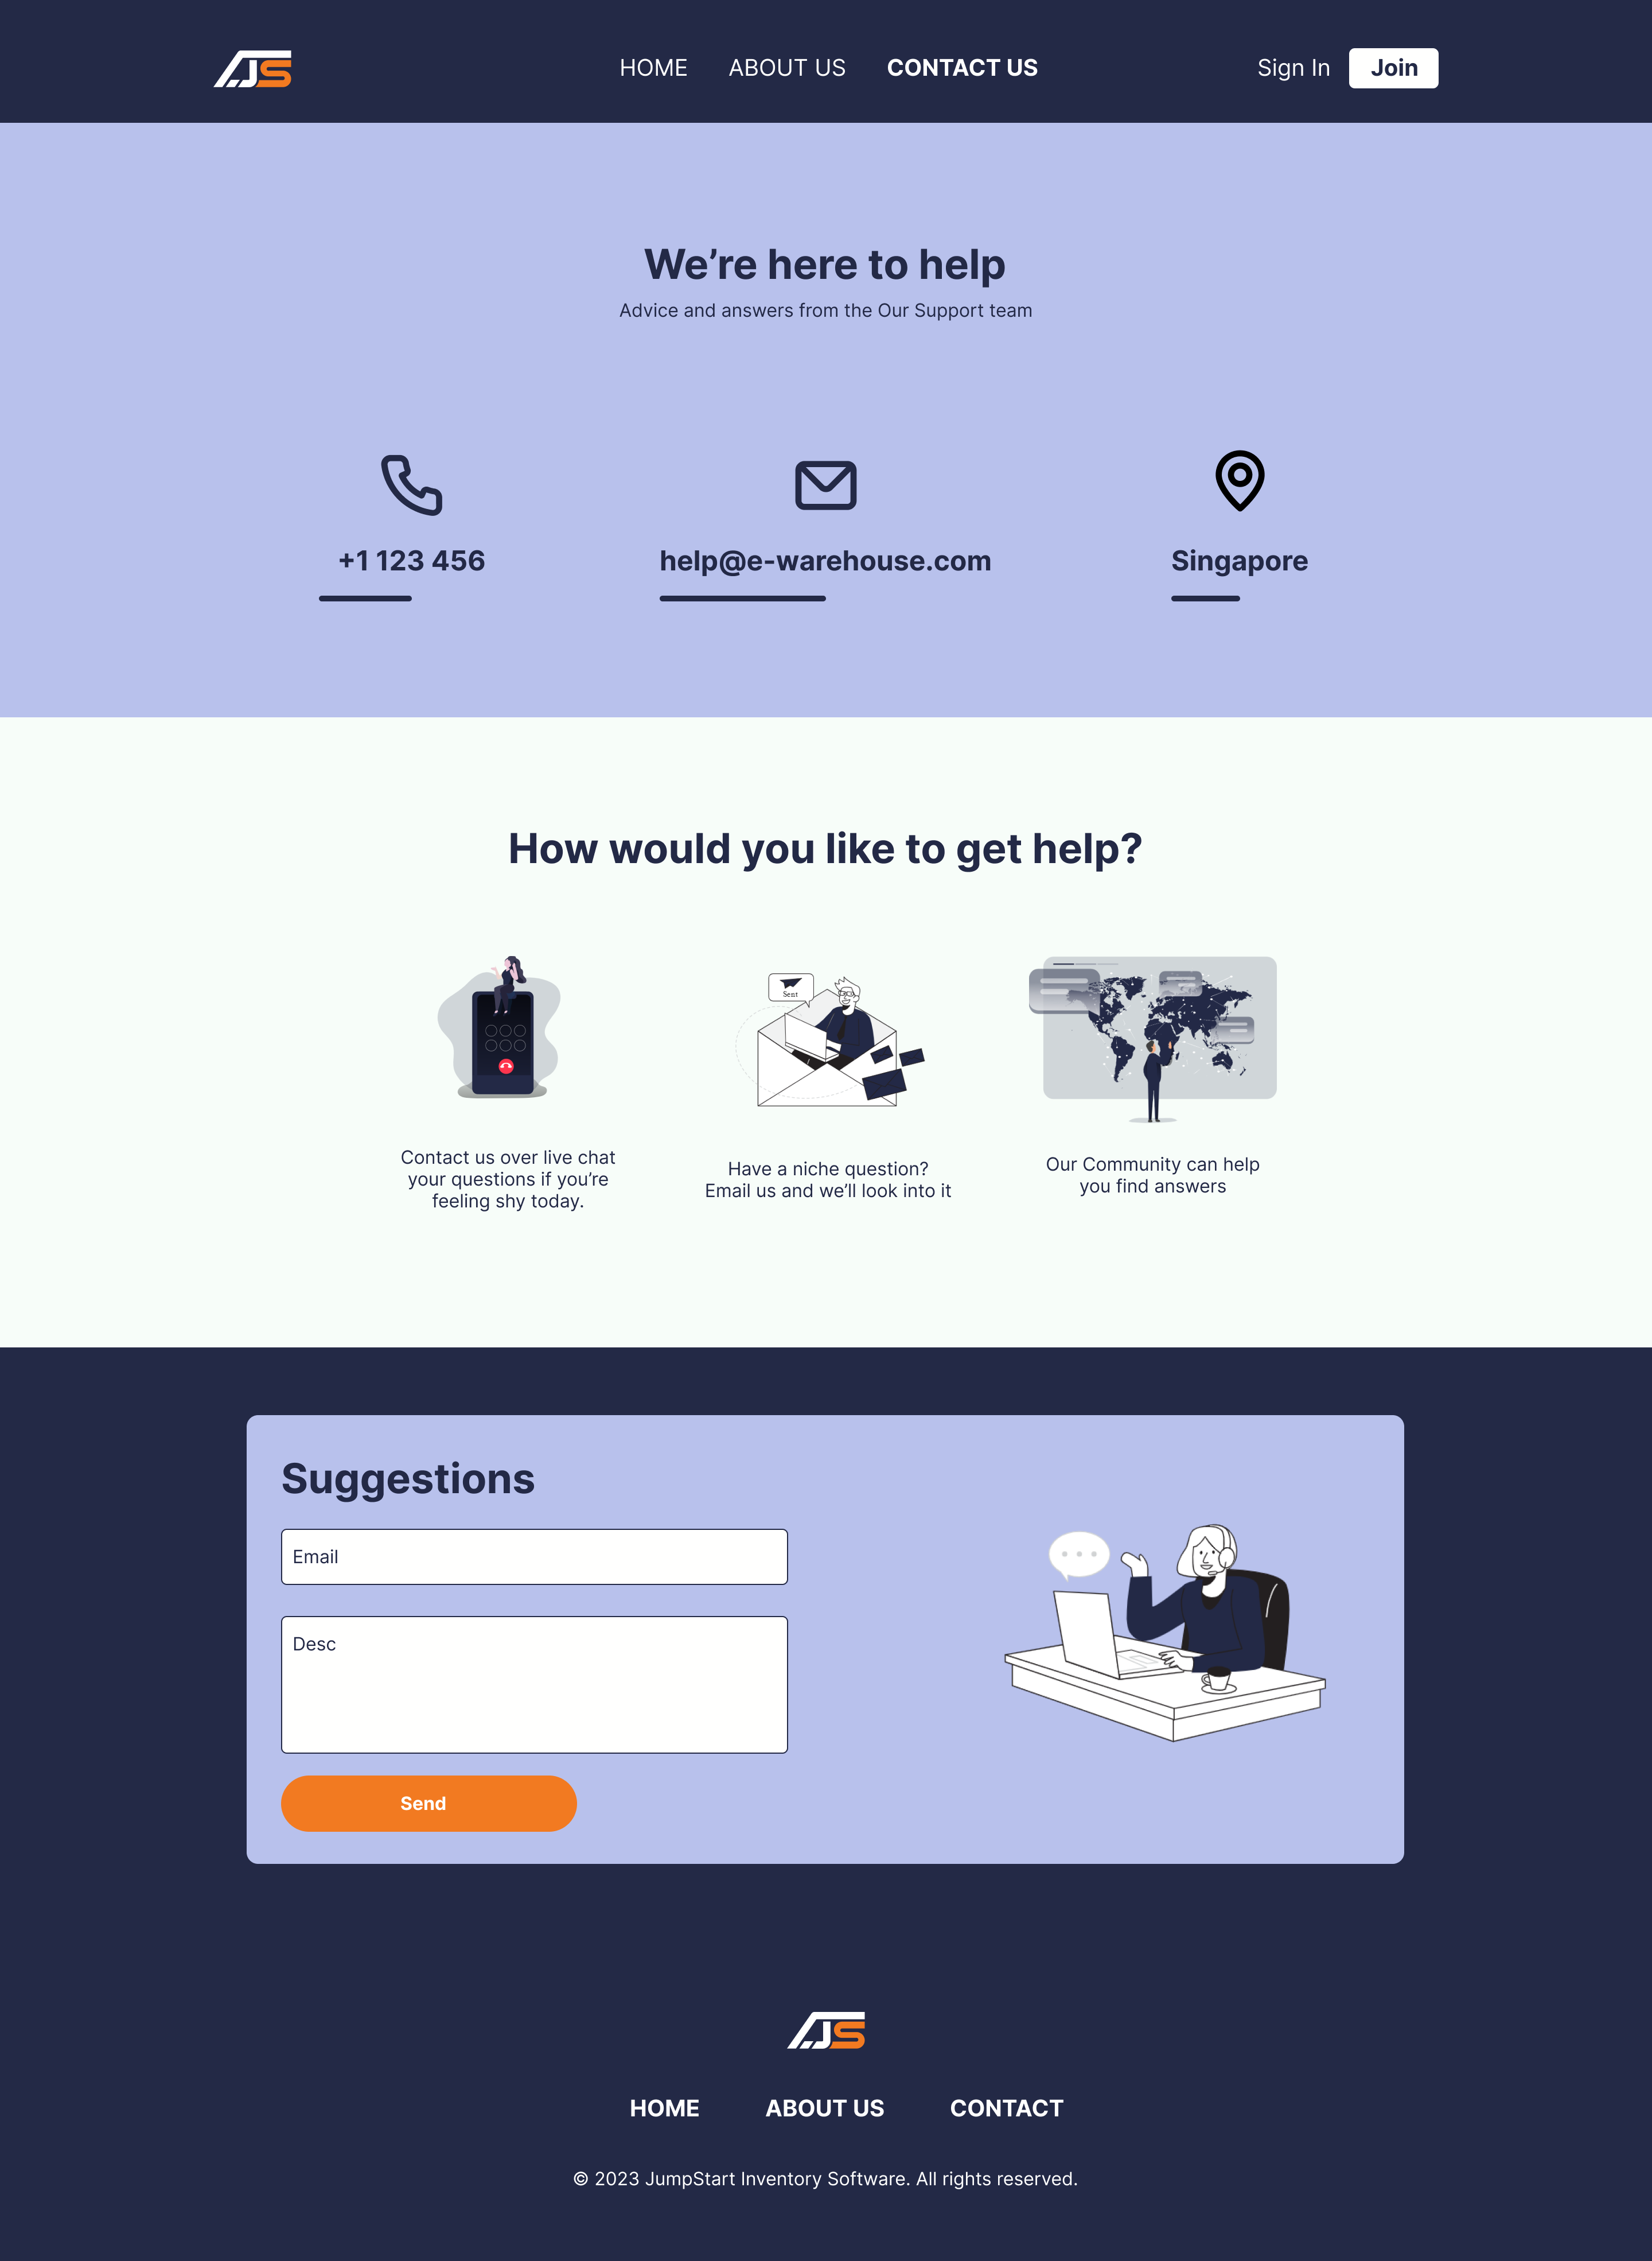

Contact Us

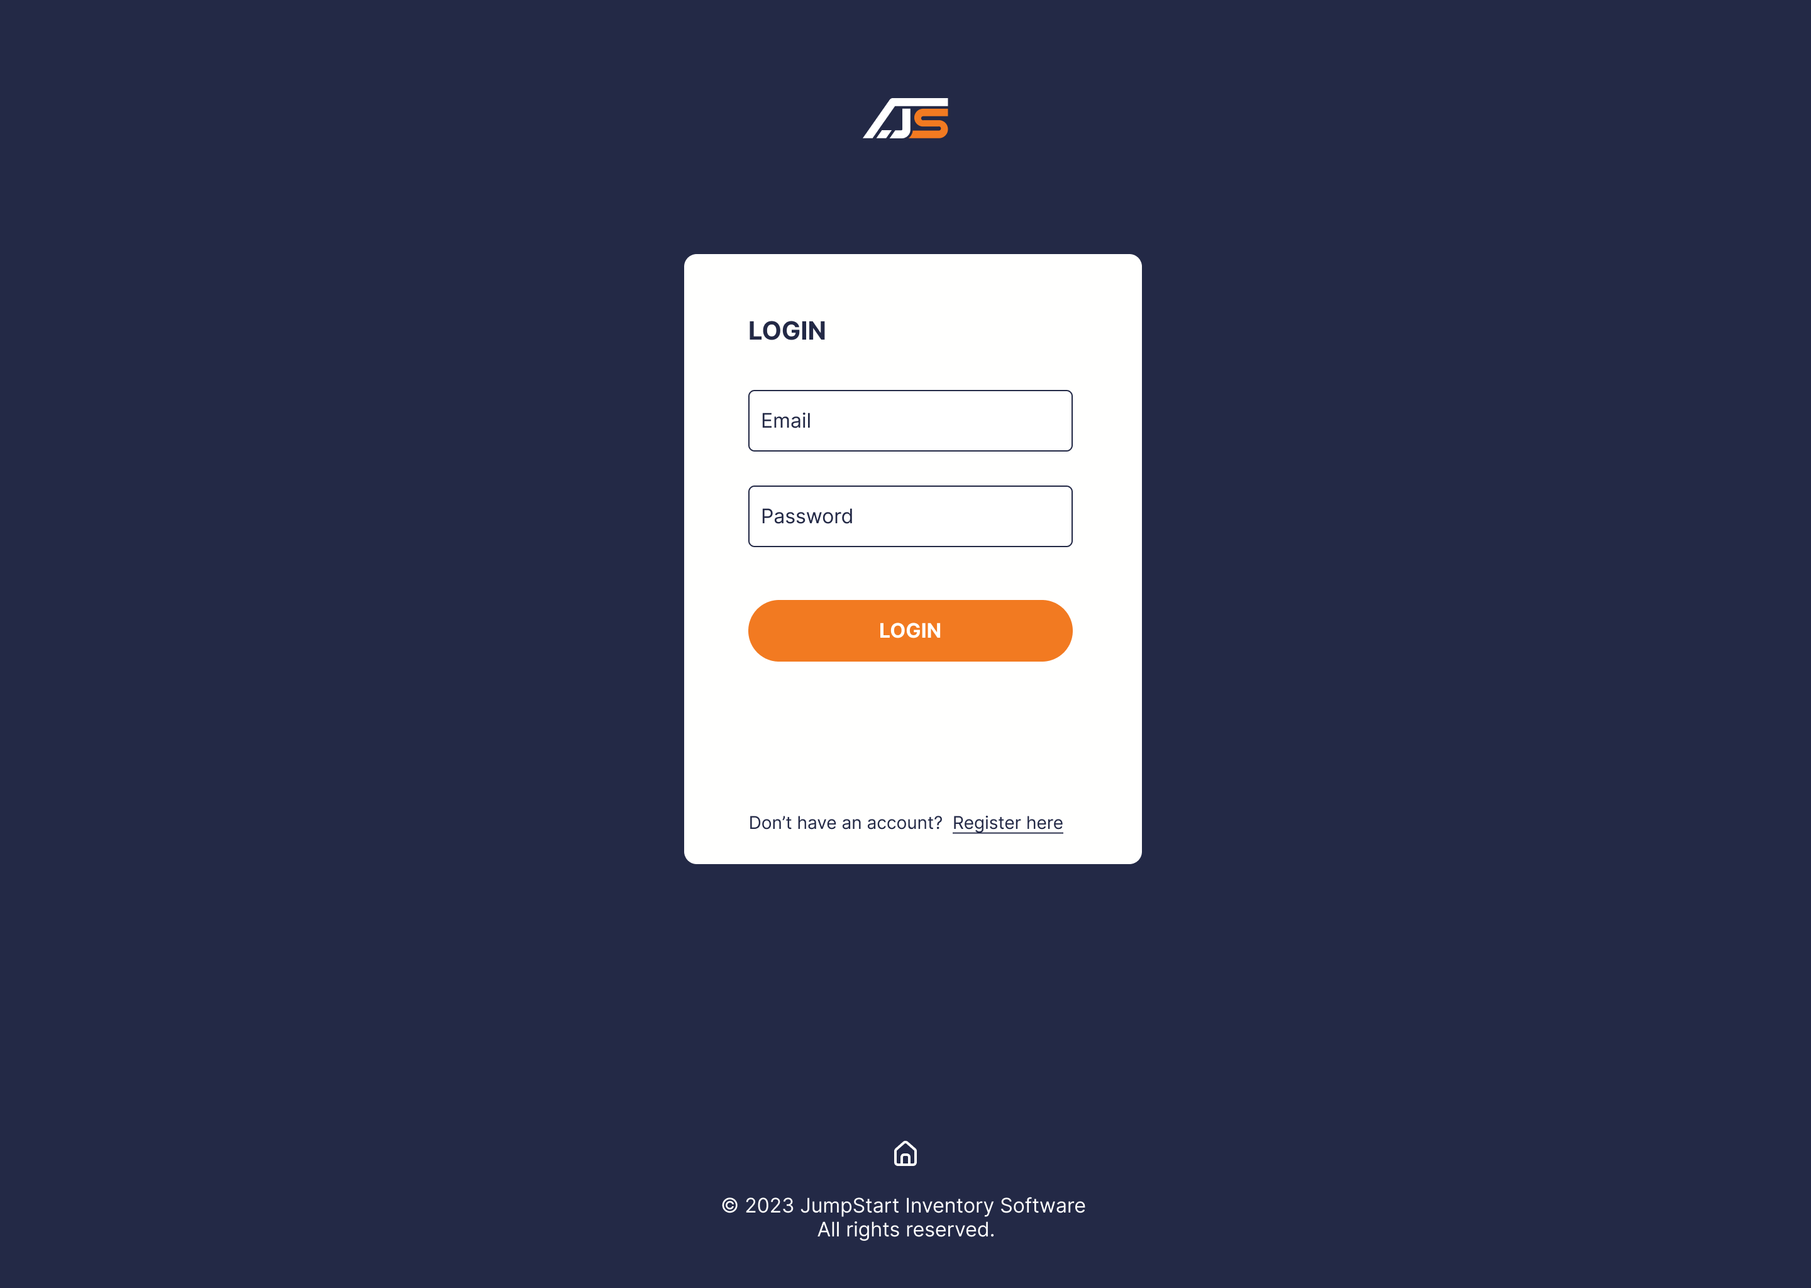

Register Page

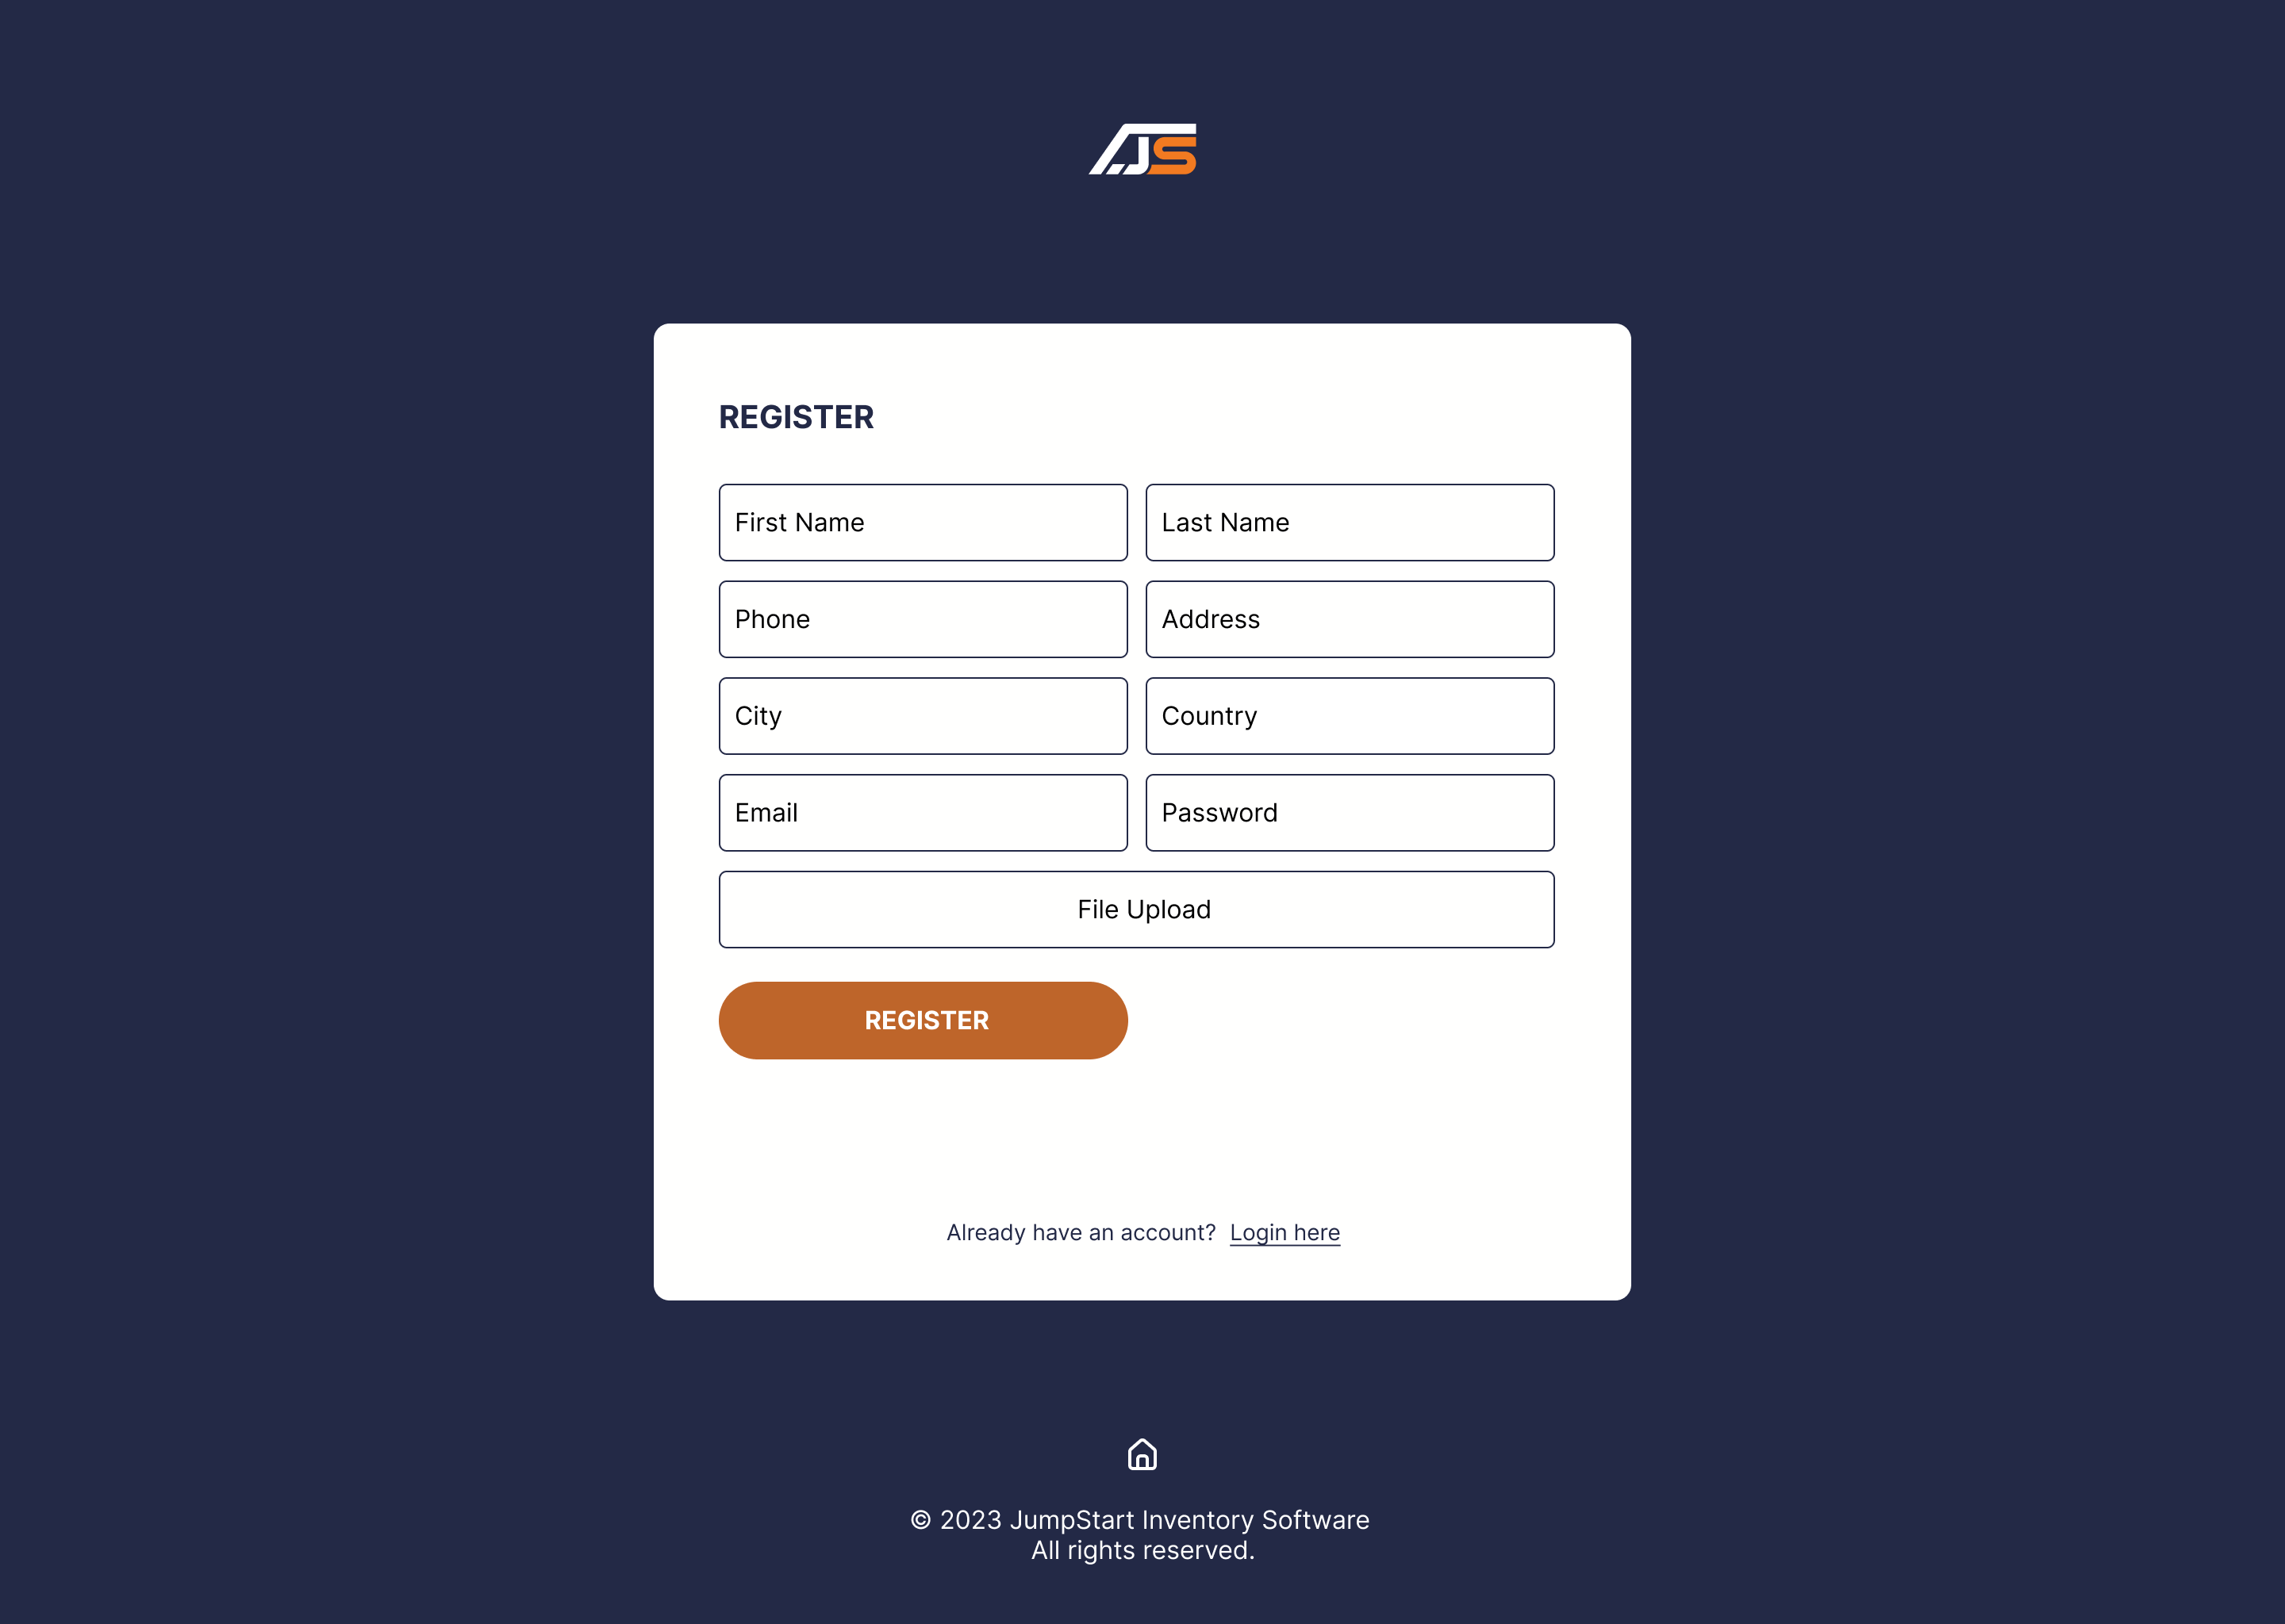

Login Page

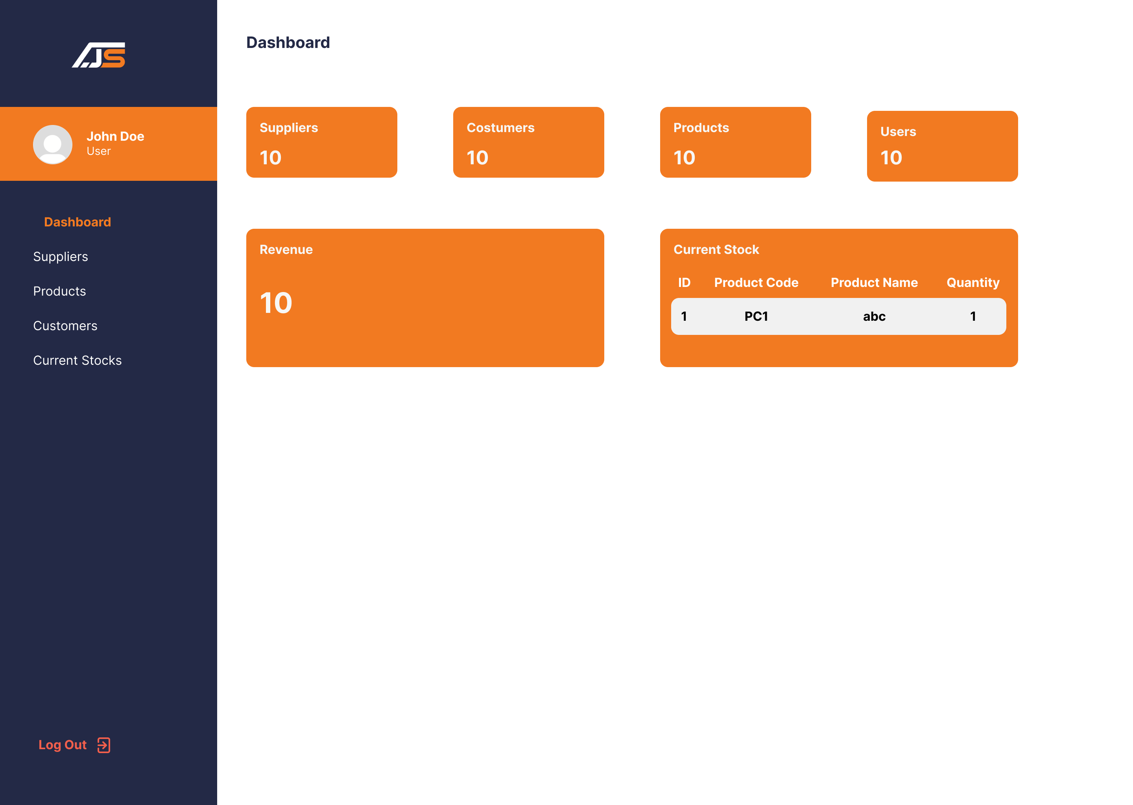

User Dashboard Page

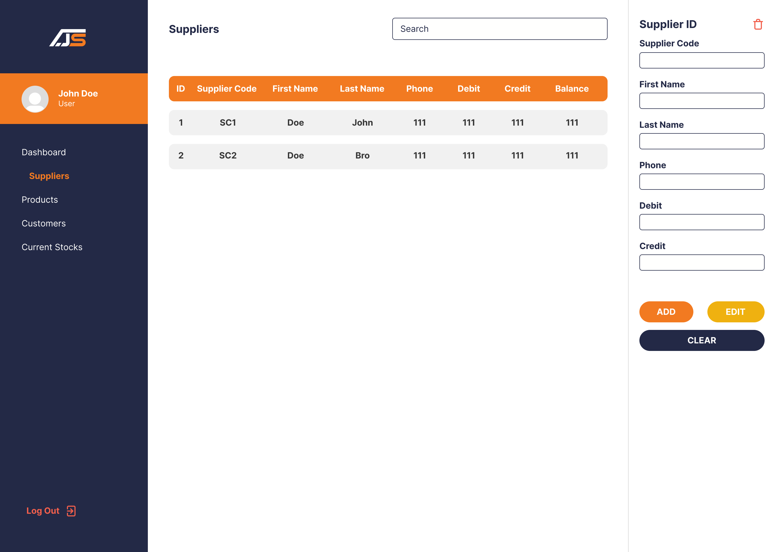

User Suppliers Page

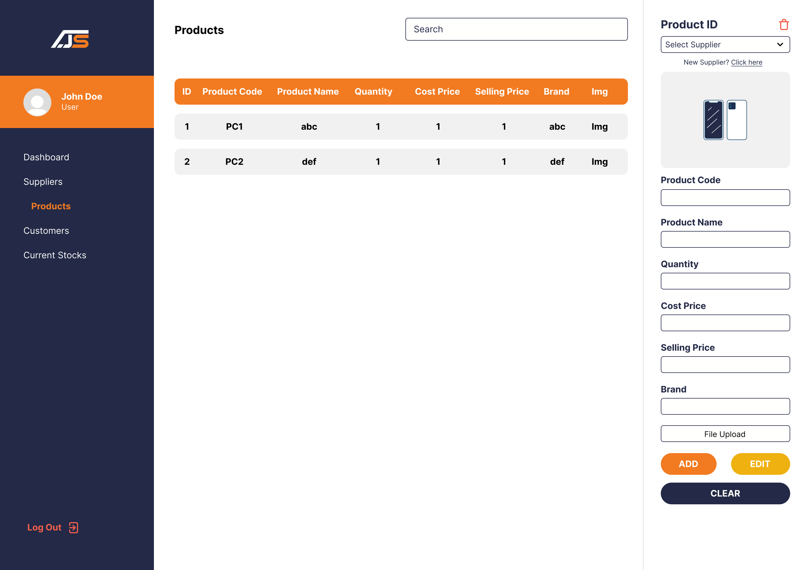

User Products Page

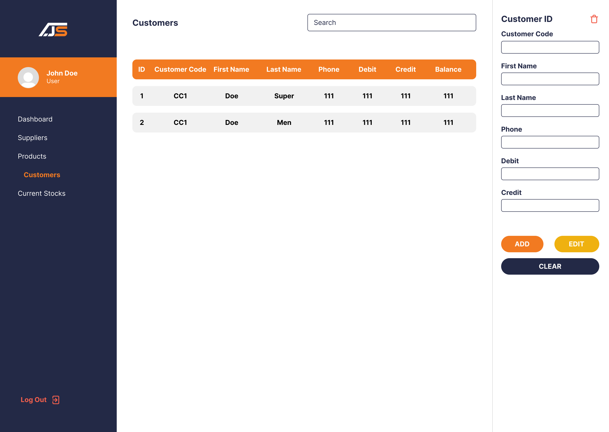

User Customers Page

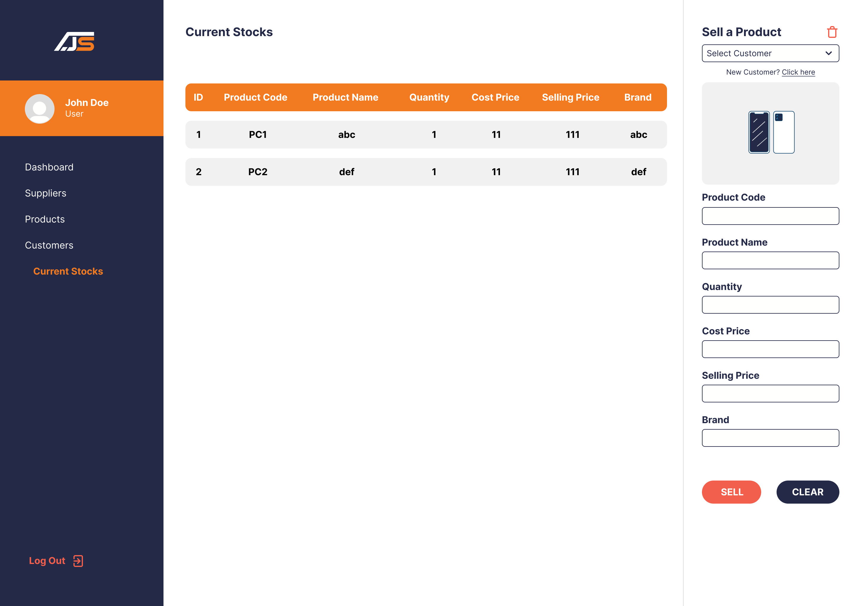

User Current Stocks Page

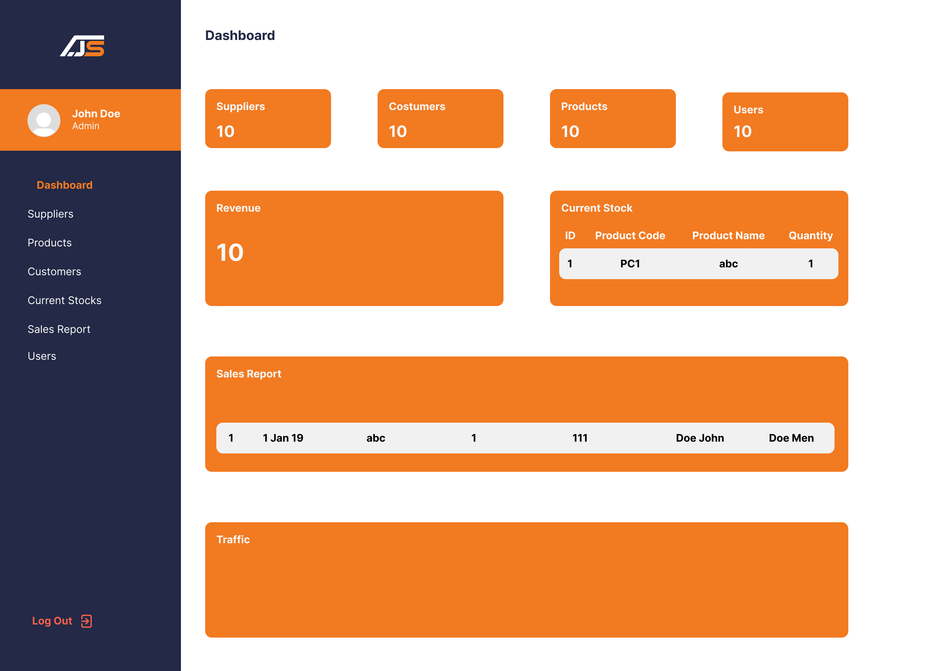

Admin Dashboard Page

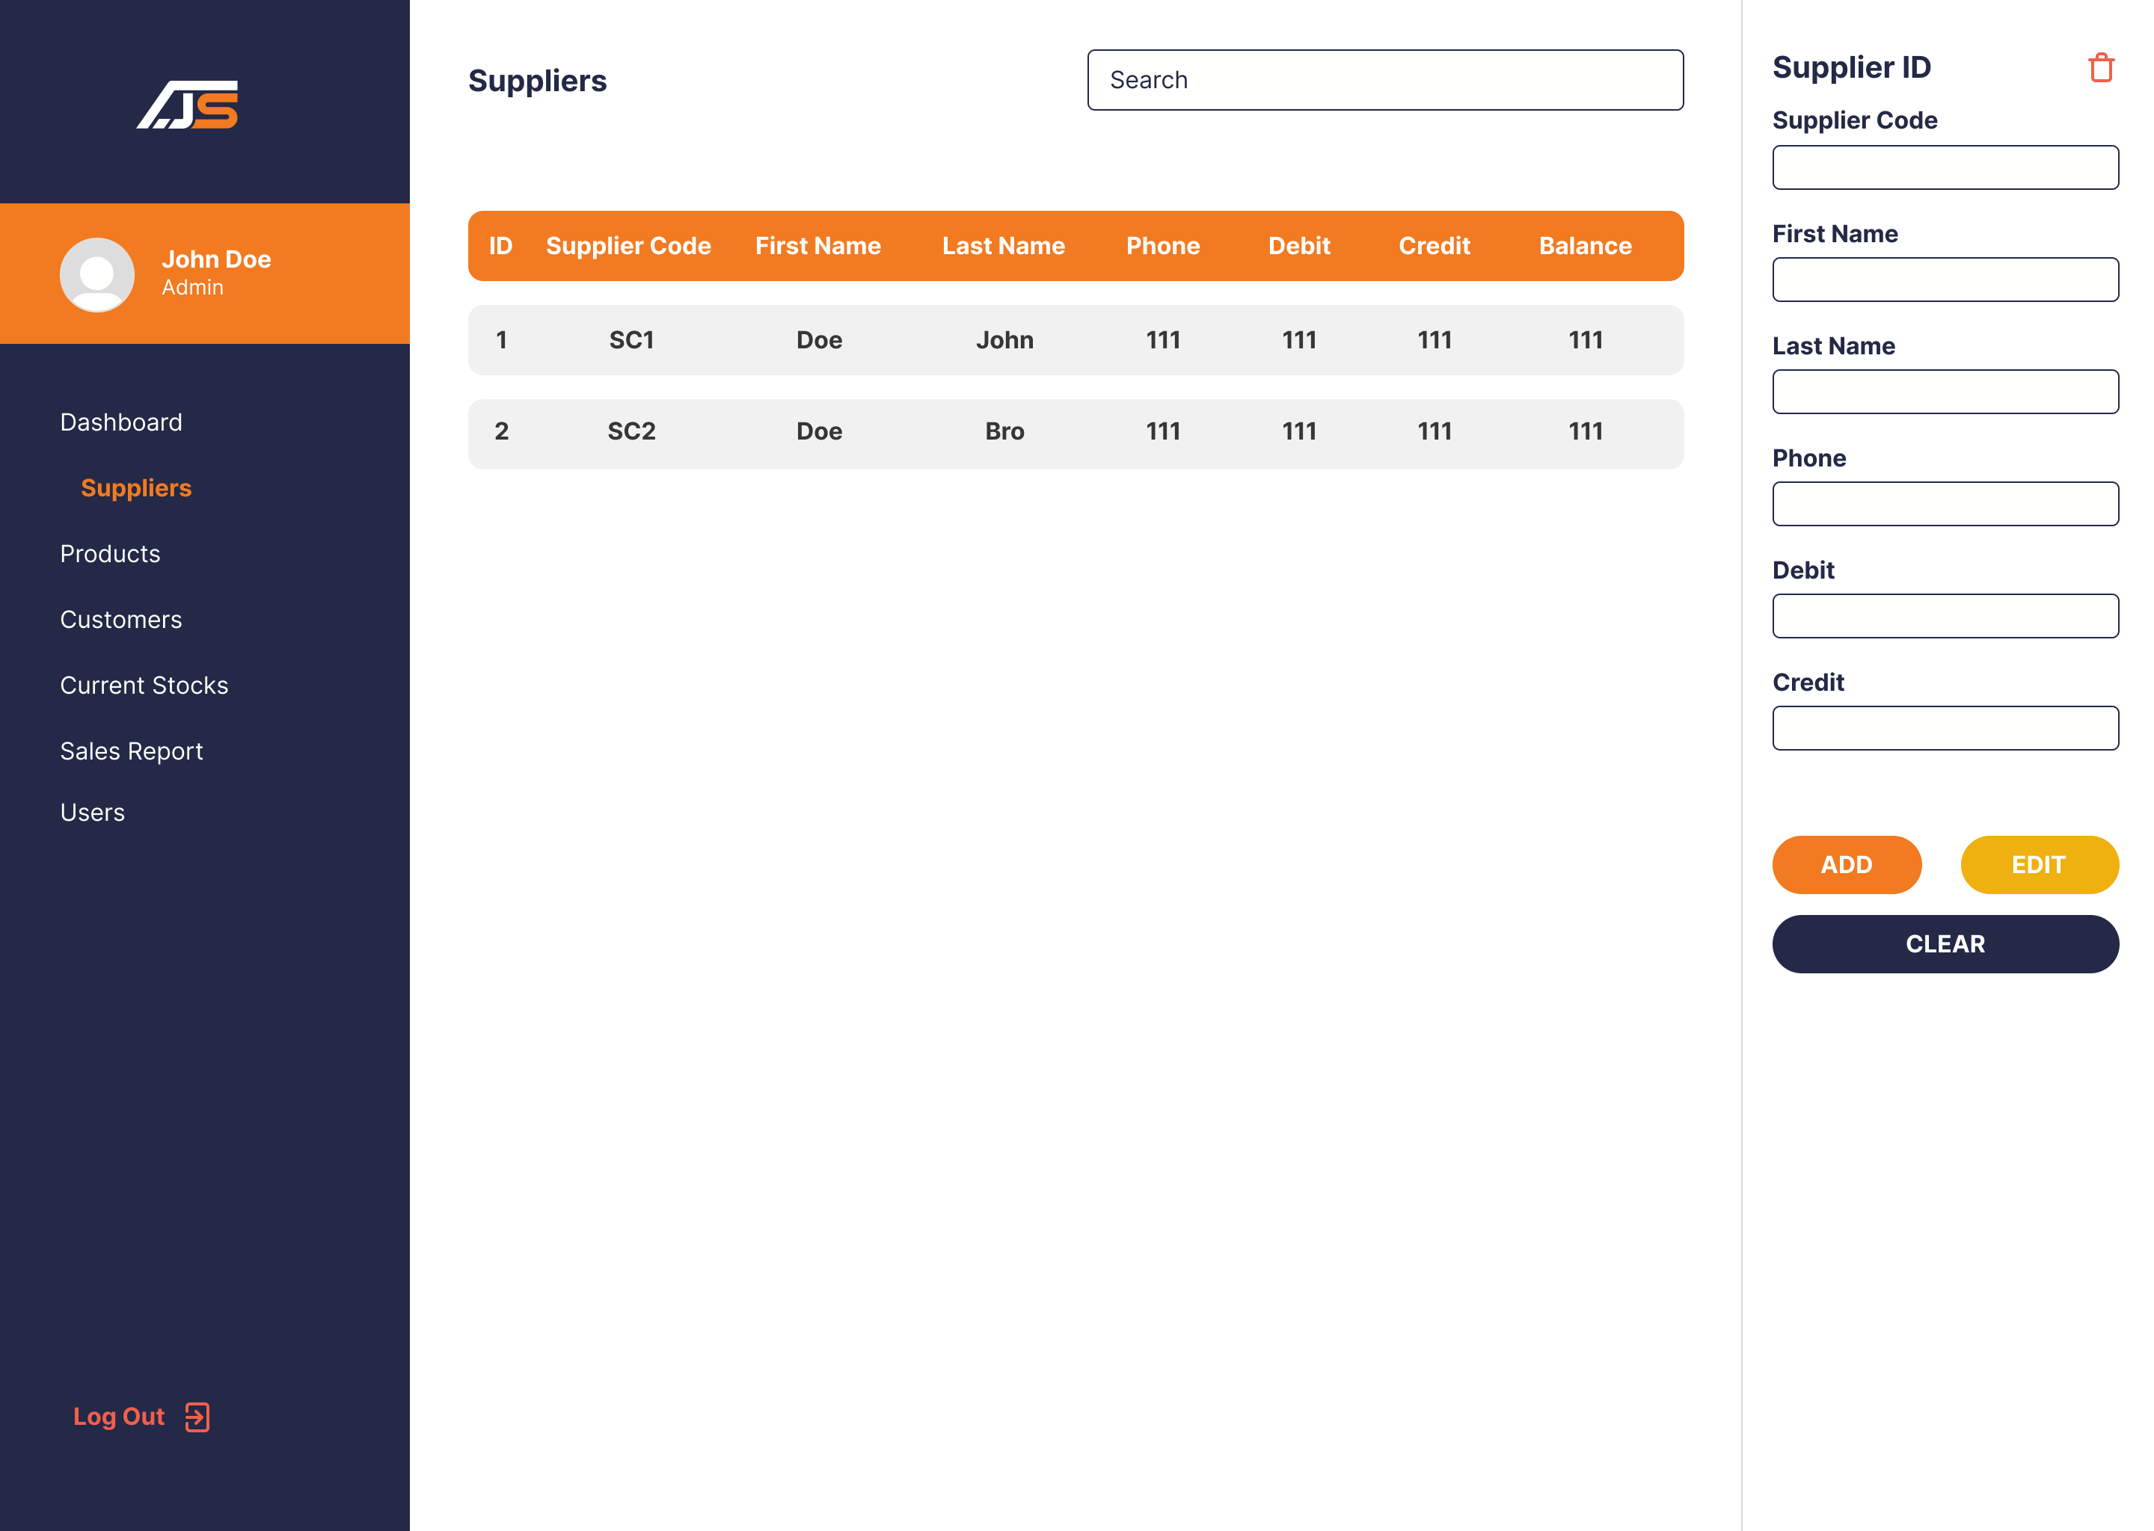

Admin Suppliers Page

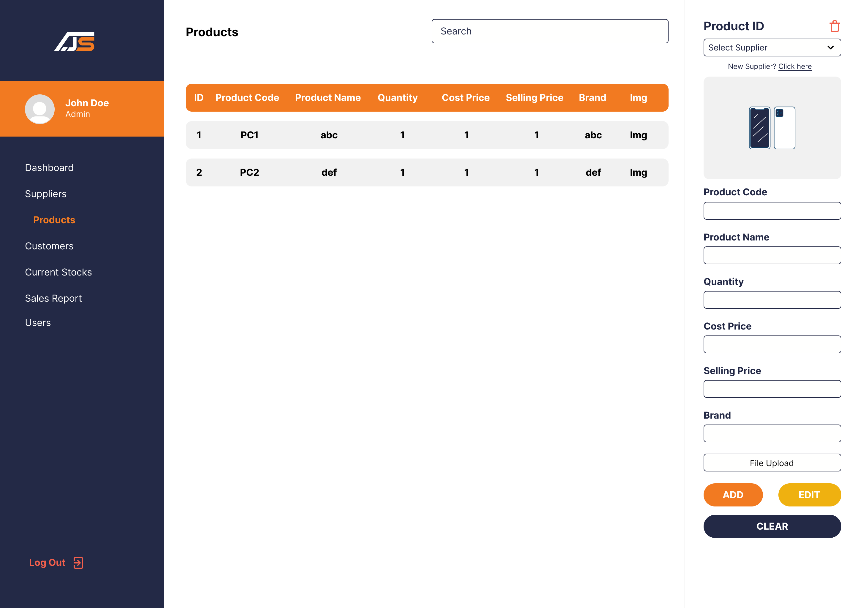

Admin Products Page

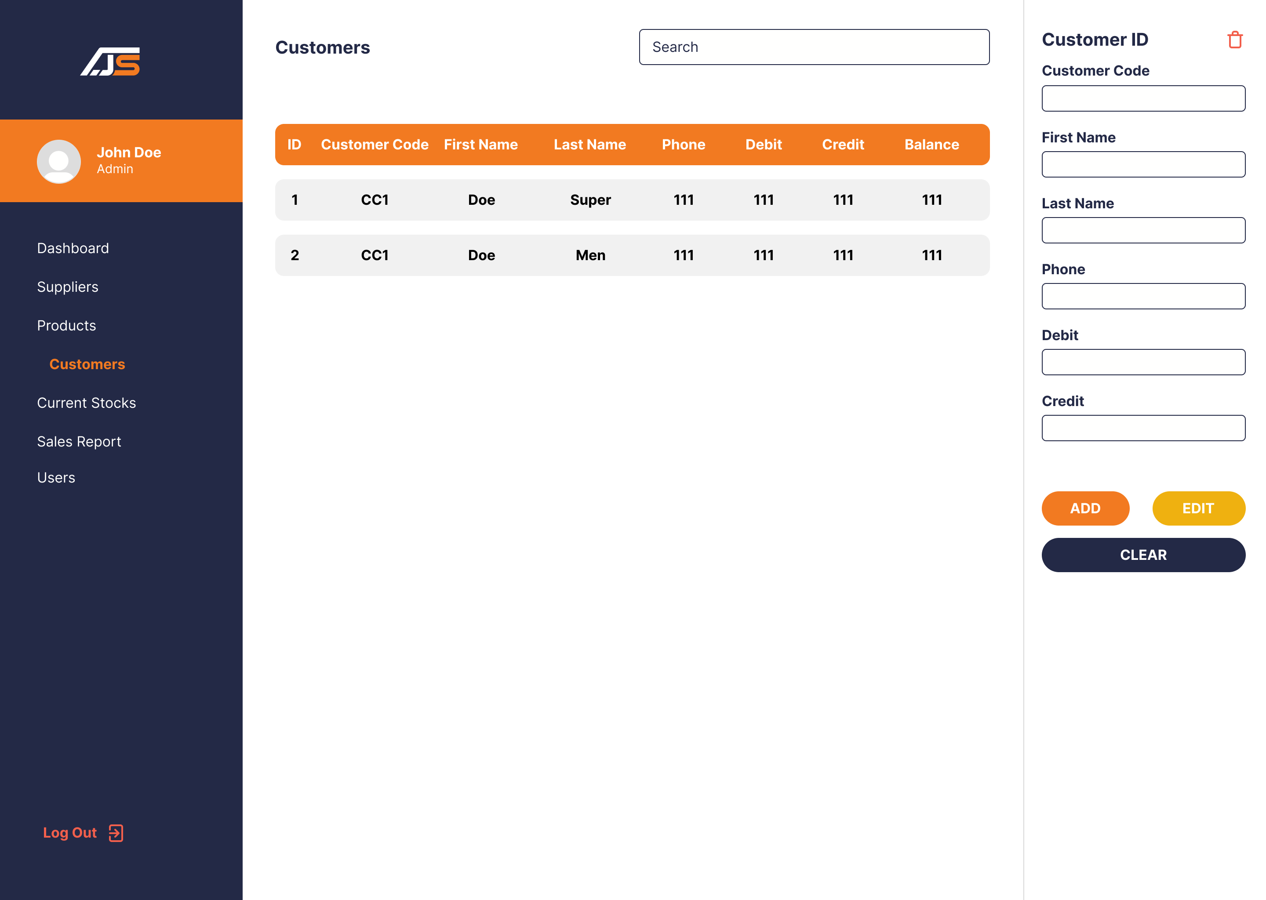

Admin Costumers Page

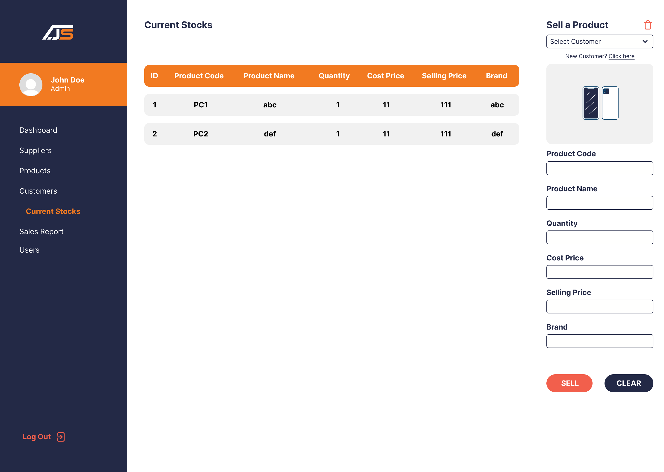

Admin Current Stocks Page

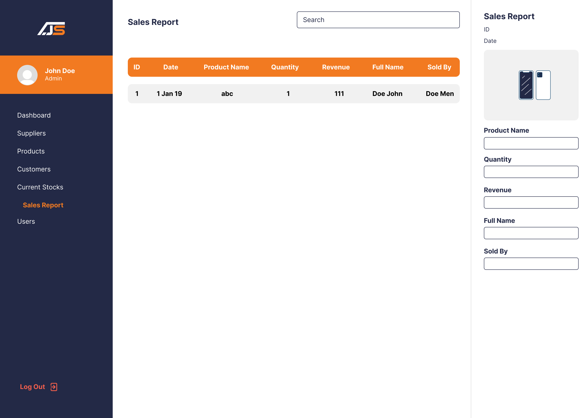

Admin Sales Report Page

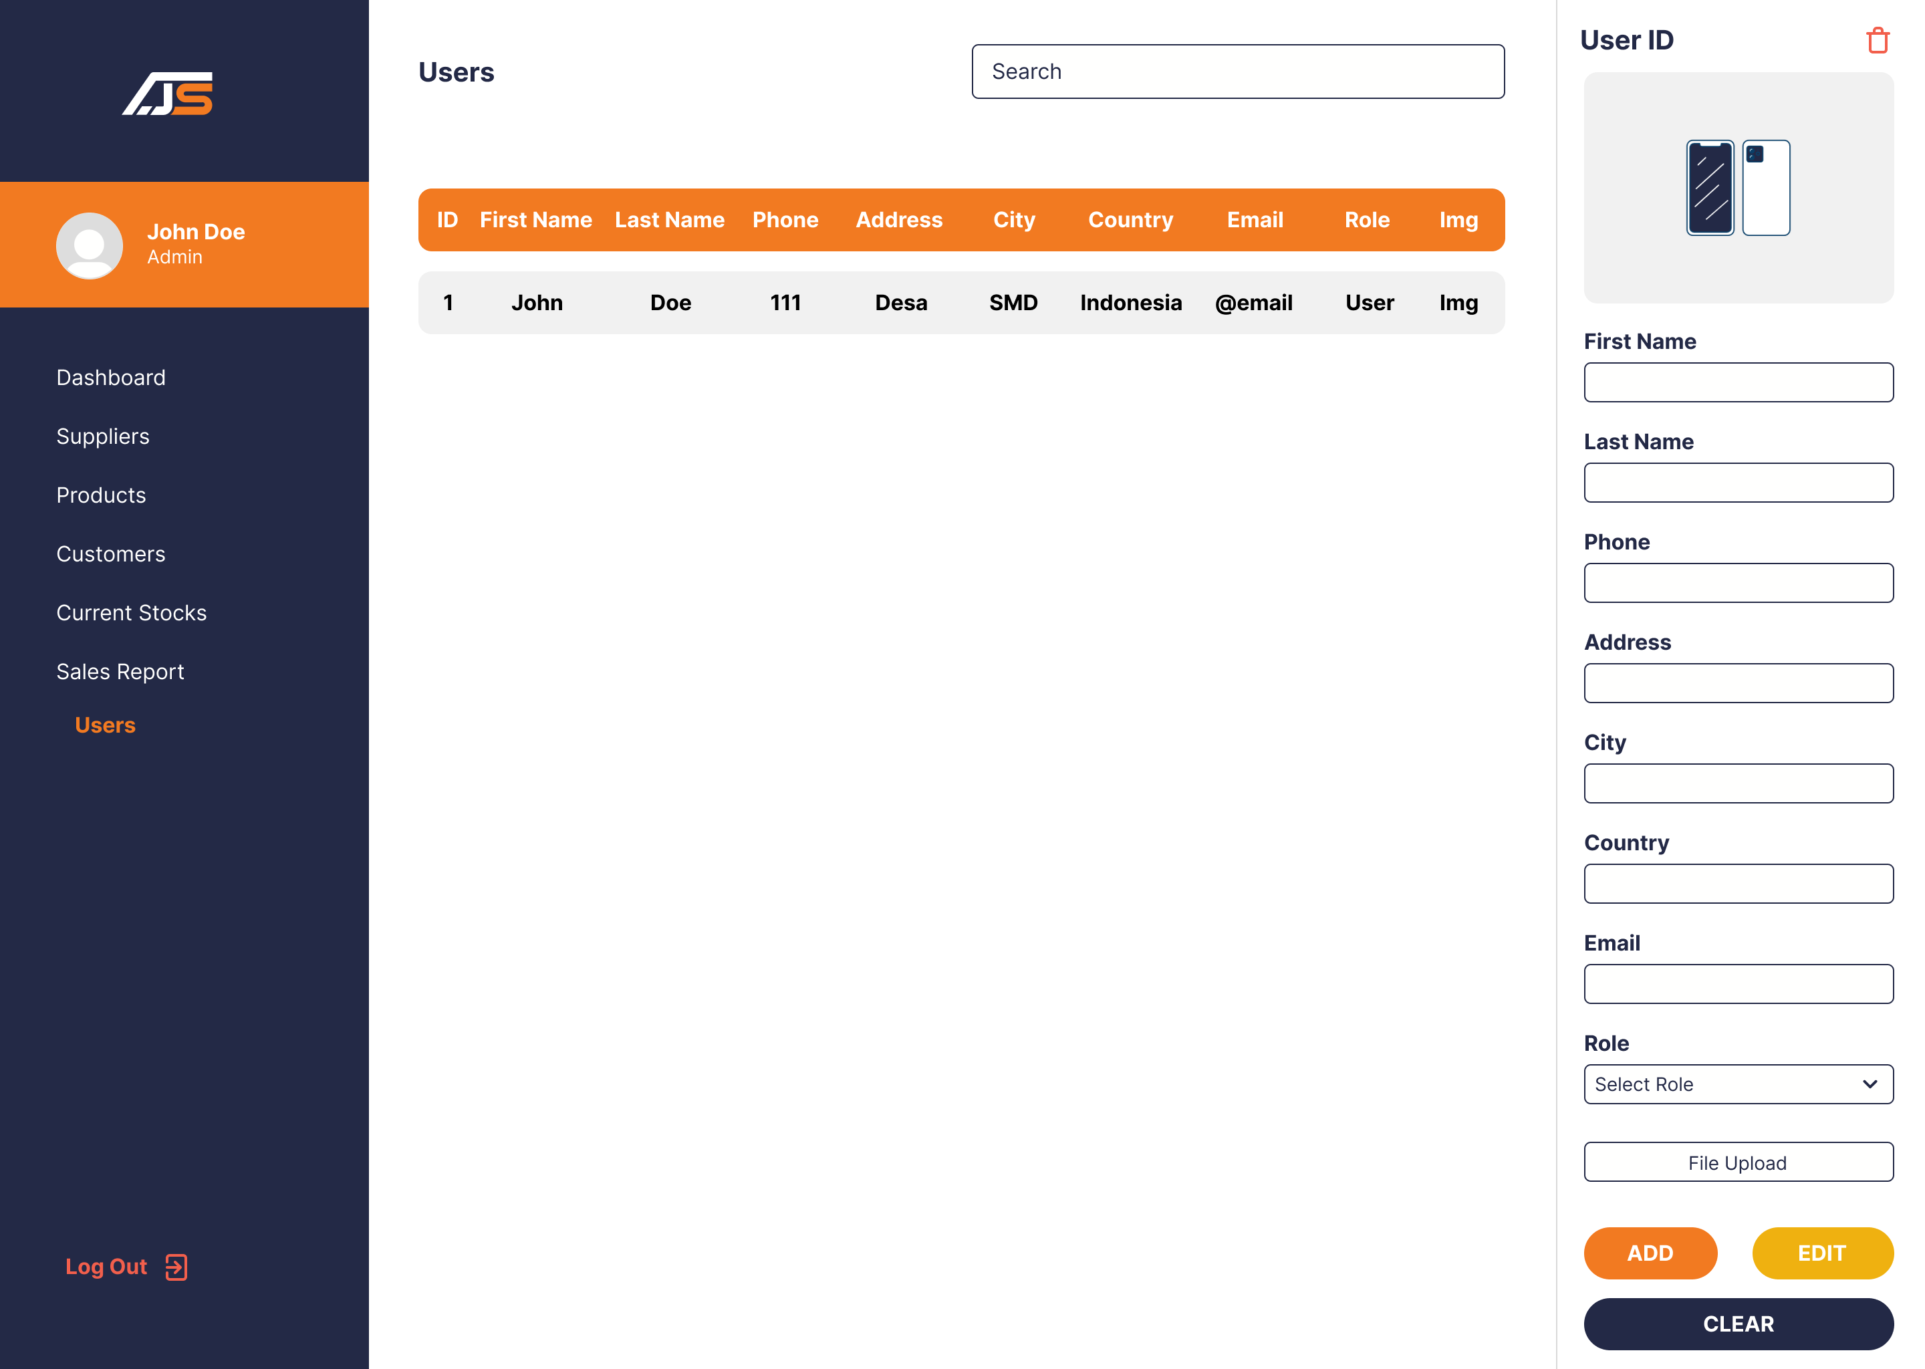

Admin Manage Users Page